Dice - SMD

Schematic description
This is a construction of electronic dice based on SMD components.
The whole construction is based on ATTINY24 microcontroller. It is powered by tiny CR1620 battery. The circuit is turned on pressing a button. Q2 and Q1 transistors are turned on when button is pressed, sourcing microcontroller with power. Microcontroller then activates PWR signal to keep transistors turned on. Button state is signalized by BTN signal that is isolated from the PWR signal by dual Schottky diode D2.

Construction
Construction has components placed on one side of the PCB. We start populating resistors, then continue with diode D2, transistors, microcontroller and LEDs. Finally populate battery holder and button.
J2 does not need to be populated. Microcontroller can be programmed using Arduino wires.

How to get it into service
It should work on the first try when everything is soldered well and microcontroller is programmed.

Bill of materials
Annotation | Value | Qty
BT1 | Keystone 3012 | 1
D1,D3,D4,D5,D6,D7,D8 | 3mm | 7
D2 | BAS70-06 | 1
J2 | 6pin | 1
Q1 | BSS84 | 1
Q2 | BC848 | 1
R1 | 2M2 | 1
R2,R3,R4,R12 | 10k | 4
R5,R6,R7,R8,R9,R10,R11 | 220R | 7
SW1 | 6x6 SMD | 1
U2 | ATtiny24-20SS | 1

PCB assembly
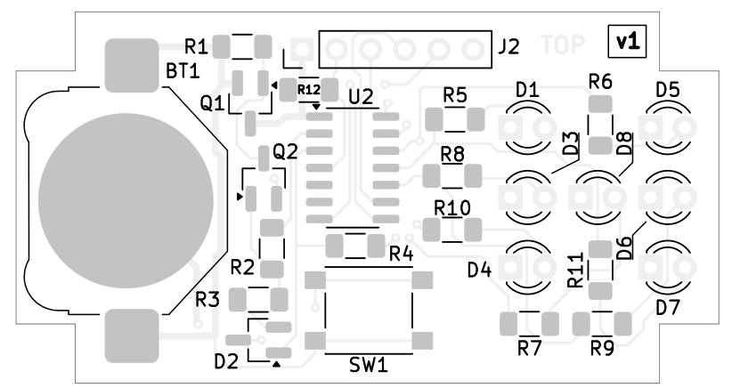

Microcontroller programming
Several programmers for Atmel AVR can be used for microcontroller programming. We’ve used Asix Presto. Following picture shows connection of Asix Presto to J2 connector (J2 pin numbers are red).

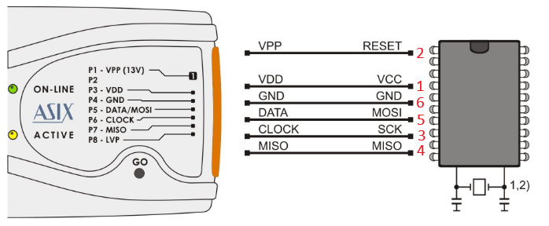

Schematic
